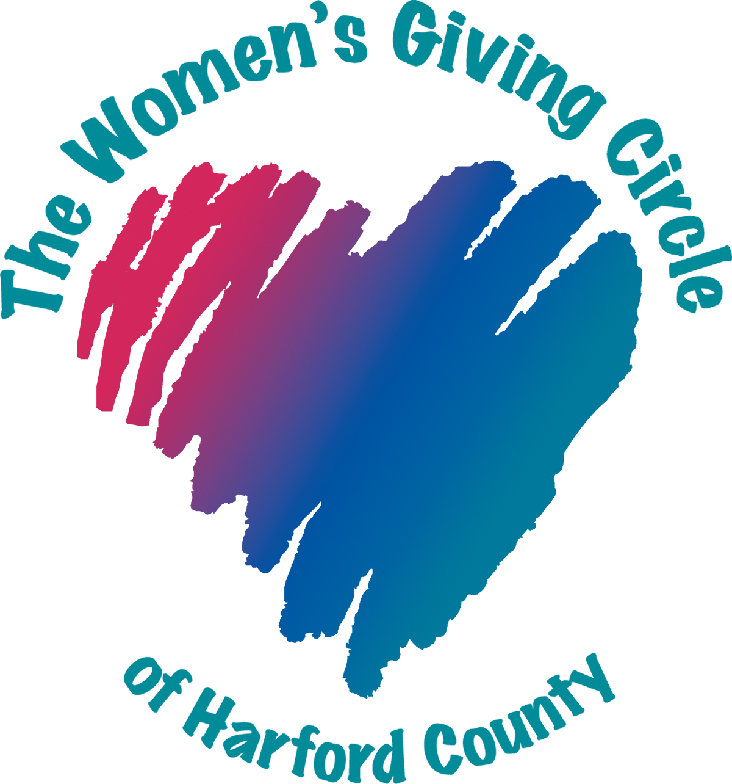
The Women’s Giving Circle of Harford County
The mission of the Women’s Giving Circle of Harford County is to engage women of all generations in the power of community philanthropy.
The vision is to empower and mentor women as they develop in community leadership and effect change through collaborative giving.
As a member of the Women’s Giving Circle, you will join a gracious and giving group of women who care deeply about the needs of our community and the nonprofits serving local women, children, and families.

Opportunities for participation abound. You can take part in the philanthropic decision-making process and have a direct role in deciding which grants to fund, join another committee, or assist with other tasks such as photographing our events. Do as little or as much as your schedule allows. We welcome any woman to join us in fulfilling our mission and vision.

Who are Women’s Giving Circle members?
Women of all ages from diverse backgrounds and all areas. Our members are dedicated, passionate and compassionate and share the mission to improve the lives of women, children, and families in Harford County. We welcome new members at any time.

If I am interested or have a friend who is interested in the Women’s Giving Circle, how can we get information?
You can learn more about the Giving Circle in a number of ways:
- Contacting the Membership Committee at: wgcharfordmembership@gmail.com;
- Attending one of our prospective member events; and/or,
- Checking our website at www.harfordwomengiving.org.

Be sure to “like” and follow us on Facebook, Instagram, and LinkedIn to check out our events.
How much is membership?
Annual membership donations vary by a member’s age. There are four membership levels:
Membership Level | Age (at Time of Payment) | Annual Membership Donation
Inspire | Under 30 years | $150
Connect | 30-40 years | $250
Empower | 41-70 years | $550
Sustain | Over 70 years | $250
These membership donations are the minimum required for membership. A member may choose to donate more if she chooses.

How much of my annual contribution is tax deductible?
Membership fees and other donations are tax deductible as allowed by law.

How is my contribution used?
The membership donation is allocated as follows: $50 goes towards an administrative fund for expenses such as software applications, name badges, etc. The remainder of the membership donation goes directly to a grant fund for grants to be awarded in the following year.

How long is my commitment when I join?
The commitment is made year to year, one year at a time. If you wish, you may pay for more than one year at a time, but typically members renew their membership annually.

When is my annual contribution due?
Fees are due by December 1st each year so we can determine how much money is available for the next year’s grant cycle. New members may join at any time and existing members may renew at any time throughout the year.

I’m ready to join! How do I pay?
Instructions are available here: https://www.harfordwomengiving.org/join/renew.

I can’t join just yet, but can I still make a donation?
YES! We welcome donations at any time, in any amount, from anyone. Thank you for your generosity!

To make a contribution to our grant fund to increase the funding available for the next round of grants, go to: https://www.harfordwomengiving.org/Donate.

To contribute to our endowed fund, the earnings from which are used to fund our Members’ Choice Award, make your check payable to the “Community Foundation of Harford County”, mark “WGC” in the memo section and send the donation to:

Community Foundation of Harford County
P.O. Box 612
Bel Air, MD 21014

Does the Women’s Giving Circle meet as a group?
Yes, there are 2-3 general membership meetings, several committee meetings, and other events throughout the year. At the general membership meetings, the Executive Board and Committee chairs present the current state of the Circle, including the grant process and the years’ grant recipients. Every other year, there is a general membership meeting for members only in January to elect the Executive Board for the next two-year term. The May general membership meeting is for members only to vote on the proposed slate of grants. The September general membership meeting is open to both members and guests to recognize the grantees. There is a holiday gathering each year and informal happy hours and other events as well. There is no obligation or expectation to attend any meeting or event.

May members bring a guest to a meeting?
Yes, members are welcome to bring a guest to the September general membership meeting. Members bringing a guest must RSVP with the guest’s name and must accompany the guest to the meeting. As noted above, the January and May general membership meetings are for members only due to the vote on Executive Board and proposed grant awards, respectively.

Do I have to join a committee?
No, not at all, but it is a great way to get involved, learn about the Women’s Giving Circle and our community, and to meet fellow philanthropists.

May I join more than one committee?
Yes, but we recommend you carefully consider the time commitment of each.

May members bring a guest to a committee meeting?
No, committee meetings are for members only.

How are grants awarded?
Members are involved in all aspects of the decision-making process associated with the grants awarded by the Women’s Giving Circle. Our grant process starts each January with the acceptance of grant applications and concludes in July with the issuance of grant funding.

Members of the Grant Committee assist in the development of the grant guidelines and application process, review and score the submitted applications, and identify those that best meet the stated criteria. There are individual and large group reviews to select the proposed slate of grantees, based on a cumulative voting process. The proposed slate of grantees is then voted upon by the Executive Board, followed by a presentation to the full membership and vote. Final recommendations from the membership are ratified by Grapevine (our fiscal sponsor for the grant fund) before disbursements are made to grantees.

Currently, the maximum annual grant award is $5,000. In addition, a nonprofit that has received a grant award for three consecutive years may not apply for a fourth year, but must take one year off before its next grant application.

How can I participate in the grant review process?
Sign up to serve on the Grant Committee when you initially join or renew your membership, or at any time while a member. However, an executive director of a nonprofit entity may not serve on the Grant Committee. Send an email to the Committee to express interest: wgcharfordcogrants@gmail.com.

How does an organization receive information about applying for a grant?
The Grant Guidelines and Application packet is issued yearly in January and shared on our Facebook page and our website. The application window typically opens in late January and closes mid-March.

Who are your typical grantees?
Our grantees are diverse. They serve women, families, and children of every ethnic, religious, racial and educational background. They inspire us to work hard on their behalf, and our grants allow them to continue to do their important work. We’re struck time after time by the legions of people working hard in the trenches with little money, enormous challenges and bigger hearts.

Information for and about our grantees is available online here: https://www.harfordwomengiving.org/Grantees.

What is the Members’ Choice Award?
The Members’ Choice Award was established in 2020 and enables all members to get involved in the grant making process. The award is funded by the earnings from our endowed fund held by the Community Foundation of Harford County. Now that the endowed fund is over $100,000, the Women’s Giving Circle may take an annual distribution from the fund’s earnings in accordance with the policy established by the Community Foundation.

The Members’ Choice Award process begins in October with members nominating a nonprofit with a budget of $1 million or less that serves women, families and children in Harford County. A member may not nominate her nonprofit employer, but is welcome to nominate another entity. Executive Board members and Members’ Choice Award Committee members are excluded from nominating. The Members’ Choice Award Committee hosts an online meeting with the nominating members who share why their nominated nonprofit deserves the award. The meeting is recorded and made available to all members to review and consider. Then, the entire membership votes on which nonprofit receives the grant. The grantee organization receiving the most member votes is announced as the Members’ Choice Award recipient on Giving Tuesday.

What is the relationship with Grapevine and the Community Foundation of Harford County?
The Women’s Giving Circle is a group of gracious and giving women who pool our funds through annual membership fees to award grants to nonprofits that serve women and their families in Harford County. We do not have a formal organization status, and so we are not a stand-alone nonprofit. The “umbrella organizations” that hold and administer the Women’s Giving Circle’s funds are Grapevine (grant fund), the Community Foundation of Harford County (endowed fund), and the Faith Based Nonprofit Resource Center (administrative fund). All are tax-exempt nonprofit organizations that manage our funds. This makes life a lot less complicated for the Women’s Giving Circle in many ways and offers our members a tax deduction for donations while also maximizing the funding available for grants.

Can I review the Women’s Giving Circle’s guidelines?
Yes, our current guidelines are available here: https://bit.ly/4bMUCJQ.

What if I have more questions?
We would love to tell you more about our group! Please email the Membership Committee at wgcharfordmembership@gmail.com and someone will be happy to speak with you.

Thank you.

Last Updated: February 2024

