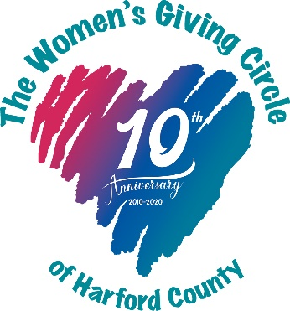

Women’s Giving Circle of Harford County
Membership Invoice for Check Payments

Please print your name, mailing and email address, and phone number below:
Name: ________________________________________________________________________
Mailing Address:________________________________________________________________
Email Address: _________________________________________________________________
Phone Number:_________________________________________________________________

Are you interested in serving on a Women’s Giving Circle committee? If yes, please indicate below:
_____ Grant Committee
_____ Membership and Outreach Committee

Please make checks payable to "Social Good Fund" in the amount of $550 or $250 (if under age 35). Include the purpose "Grapevine DAF: Women's Giving Circle of Harford County" in the memo line. (Please note: Our WGC membership funds are held by the Social Good Fund, which is the Donor-Advised Fund for Grapevine.)

Mail this invoice along with your check made payable to Social Good Fund to:
Women’s Giving Circle of Harford County
P.O. Box 94
Bel Air, MD 21014

You will receive confirmation of your payment once it has been processed by Grapevine. Note: It can take over a month to process check payments.

Thank you for your continued commitment to the WGC and local philanthropy!

